Project Phase 1:
Exploratory Analysis Report

Introduction
This report presents an exploratory analysis of daily bike sharing demand using the Bike Sharing dataset. The objective is to understand how calendar and weather-related factors influence daily rental counts (cnt) and to develop an initial regression model that generalizes to new data. As required, data from 2011 are used for model development, and data from 2012 are reserved for evaluation.
The analysis focuses on the following predictors: season, month, holiday, weekday, working day, weather situation, temperature, apparent temperature, humidity, and wind speed. These variables represent temporal structure and environmental conditions that plausibly affect bike usage.

Data Description and Preparation
The daily dataset contains one observation per day with total rental counts and associated calendar and weather variables. The response variable is the total number of rentals per day (cnt). The variable yr is used to split the data into training (2011, yr = 0) and testing (2012, yr = 1) sets.
Categorical predictors (season, month, holiday, weekday, working day, and weather situation) are treated as factors. Continuous predictors (temperature, apparent temperature, humidity, and wind speed) are retained on their normalized scales. The daily data contain no missing values, so no imputation or row removal is required.
Variable | Type | Min | Max | Mean
cnt | Response | 22 | 8714 | 4504.3488372093025
season | Categorical | 1 | 4 | 2.496580027359781
mnth | Categorical | 1 | 12 | 6.519835841313269
holiday | Categorical | 0 | 1 | 0.028727770177838577
weekday | Categorical | 0 | 6 | 2.997264021887825
workingday | Categorical | 0 | 1 | 0.6839945280437757
weathersit | Categorical | 1 | 3 | 1.3953488372093024
temp | Continuous | 0.0591304 | 0.861667 | 0.495384789
atemp | Continuous | 0.0790696 | 0.840896 | 0.47435398864569084
hum | Continuous | 0 | 0.9725 | 0.6278940629274967
windspeed | Continuous | 0.0223917 | 0.507463 | 0.190486212
Table 1. Summary of variables used in the analysis (response and predictors).

Exploratory Data Analysis (2011)
All exploratory analysis in this section is based only on the 2011 training data.

Response Variable: Daily Counts (cnt)
Daily rental counts vary substantially across the year. Usage is lowest in winter and highest in late spring and summer. The distribution of cnt is right-skewed, with most days between approximately 1,000 and 5,000 rentals and a smaller number of very high-demand days.
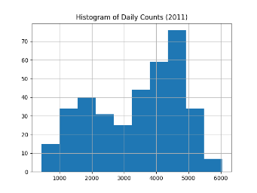
Figure 1. Histogram and boxplot of daily rental counts (cnt) for 2011.

Categorical Predictors
- Season: Summer and fall have the highest median daily counts, while winter has the lowest.
- Month: Demand increases from January through June, peaks in mid-summer, and declines into winter.
- Holiday: Holidays show slightly lower average usage than non-holidays.
- Weekday: Weekdays have higher average counts than weekends.
- Working Day: Working days have higher counts than non-working days.
- Weather Situation: Better weather categories correspond to higher usage, while adverse weather is associated with reduced demand.
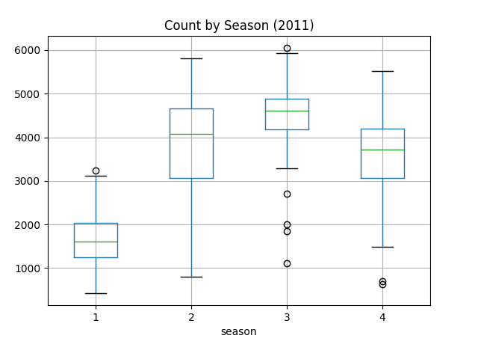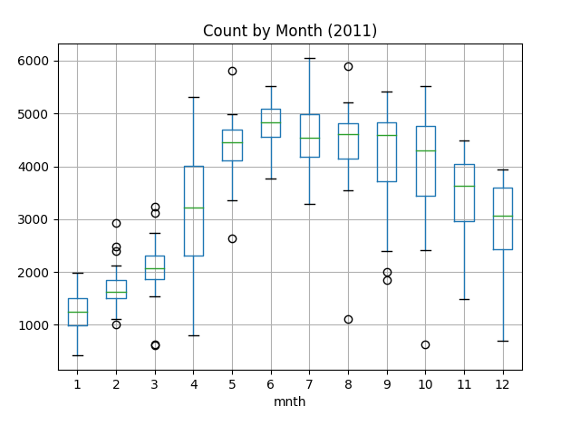
Figure 2a) Season Figure 2b) Month
Figure 2. Boxplots of cnt by season and month (2011).
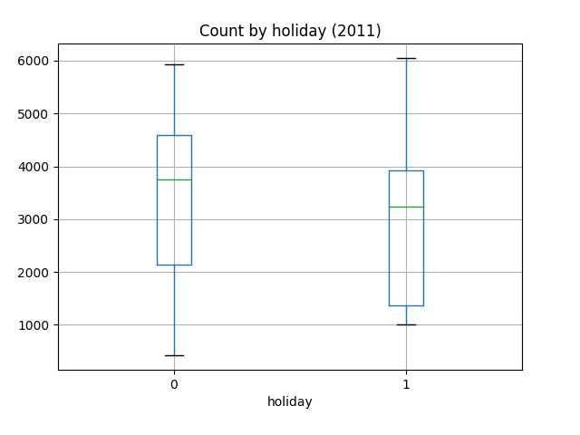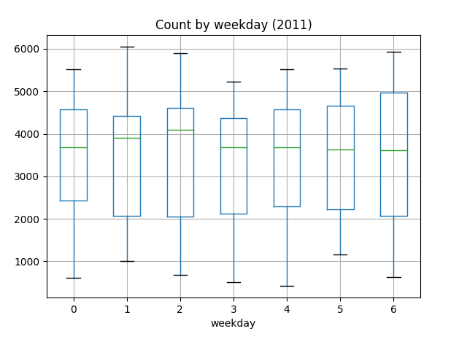
Figure 3a) Holiday Figure 3b) Weekday
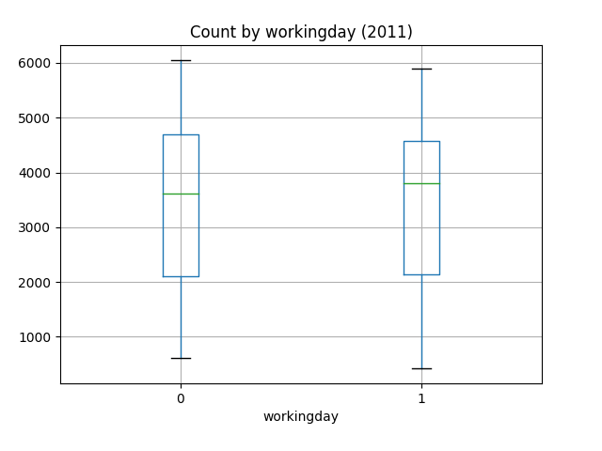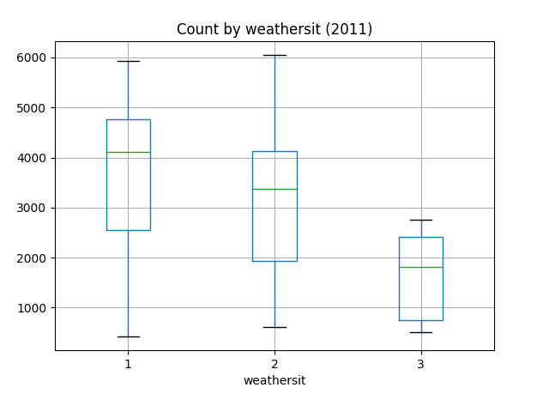
Figure 3c) Working day Figure 3d) Weather Situation
Figure 3. Boxplots of cnt by holiday, weekday, working day, and weather situation (2011).

Continuous Predictors
- Temperature (temp) and Apparent Temperature (atemp): Both show strong positive relationships with daily counts. Warmer days are associated with substantially higher usage.
- Humidity (hum): Higher humidity is associated with lower usage.
- Wind Speed (windspeed): Higher wind speeds correspond to slightly reduced demand.
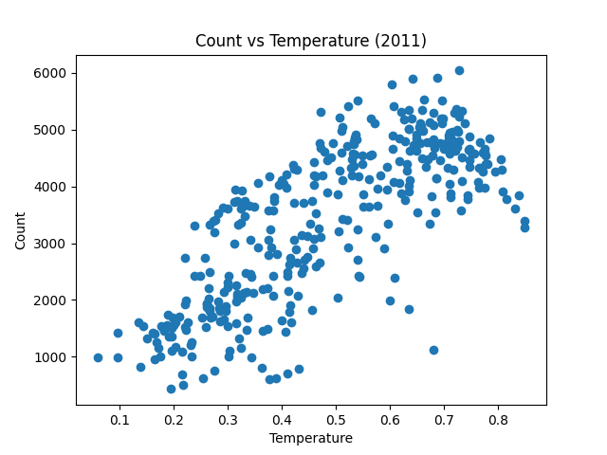
Figure 4. Scatterplots of cnt versus temperature and apparent temperature (2011).
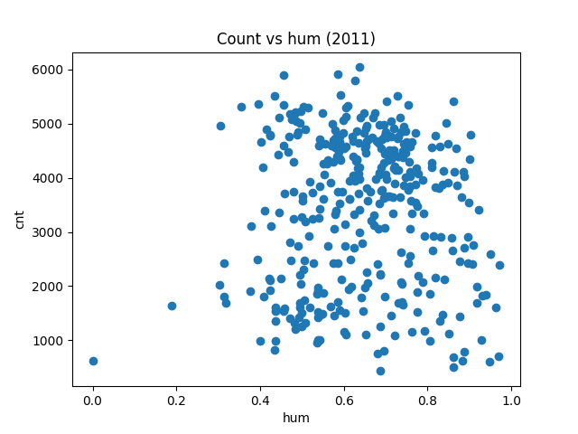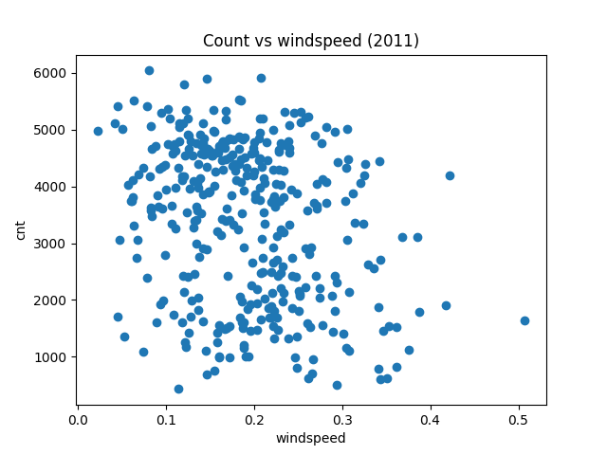
Figure 5a) Humidity Figure 5b) Windspeed
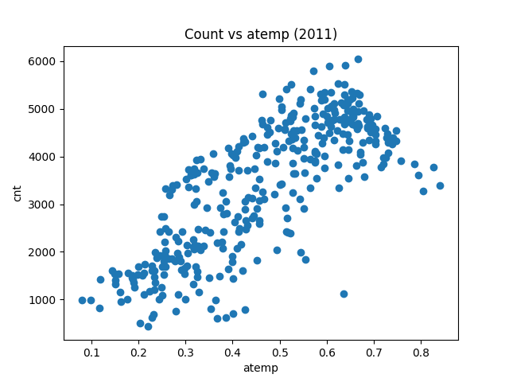
Figure 5c) Apparent temperature
Figure 5. Scatterplots of cnt versus humidity and wind speed (2011).
Overall, temperature-related variables and seasonal structure dominate the variation in daily demand.

Single-Predictor Regression Models (2011)
Separate linear regression models are fit using cnt as the response and each predictor individually.
- Temperature and Apparent Temperature: These yield the highest R² values and have strong, statistically significant positive coefficients.
- Season and Month: Both explain a substantial fraction of the variance and capture broad seasonal trends.
- Humidity and Wind Speed: Both are statistically significant with negative coefficients but explain less variance than temperature.
- Holiday, Weekday, and Working Day: These show statistically significant but smaller effects.
Residual diagnostics show heteroskedasticity and mild departures from normality for most models, which is expected given the strong seasonal structure and the count-based nature of the response.
Predictor | R2 | Effect_direction | Significance
season | 0.294 | positive | significant
mnth | 0.198 | positive | significant
holiday | 0.002 | negative | not significant
weekday | 0 | negligible | not significant
workingday | 0 | positive | not significant
weathersit | 0.101 | negative | significant
temp | 0.595 | positive | significant
atemp | 0.601 | positive | significant
hum | 0 | negative | not significant
windspeed | 0.077 | negative | significant
Table 2. Coefficient estimates, standard errors, p-values, and R² for all single-predictor models.
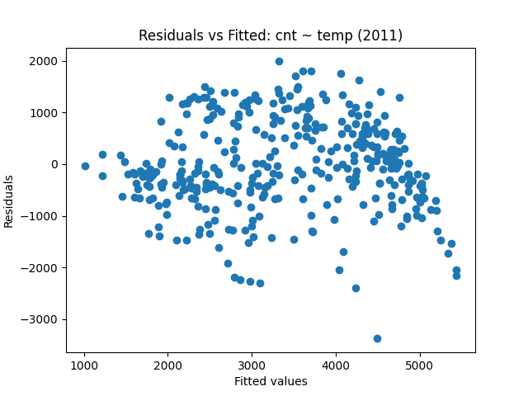
Figure 6. Residual diagnostics from representative single-predictor models (e.g., cnt ~ temp) show heteroskedasticity and mild departures from normality, which is expected given the strong seasonal structure and the count-based nature of the response.

Interaction Models (2011)
Three two-predictor models with interaction terms are examined:
- Temperature × Humidity: To test whether the effect of temperature depends on moisture in the air.
- Season × Weather Situation: To test whether adverse weather has different effects across seasons.
- Working Day × Weekday: To test whether weekday effects differ between working and non-working days.
The temperature-humidity interaction is not statistically significant, indicating little evidence that the effect of temperature on demand depends on humidity levels. The season-weather interaction shows moderate evidence that adverse weather reduces demand more strongly in summer than in winter. The working day-weekday interaction provides weak evidence and does not materially improve model fit.
Model | Interaction_p | R2
temp*hum | 0.5811459116157643 | 0.6075841743931852
season*weathersit | 0.002278945 | 0.7004165904057189
workingday*weekday | 0.9405130396040893 | 0.000465565
Table 3. Coefficient estimates and p-values for the three interaction models.
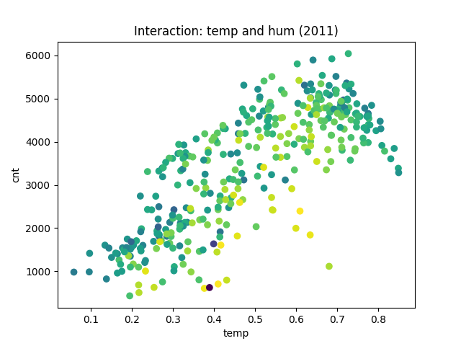
Figure 7. Interaction plot for temperature and humidity (2011).

Backward Selection Final Model (2011)
Starting from a full model containing all predictors and the explored interactions, backward selection was used to simplify the model while preserving key predictors identified in earlier exploratory analyses. The final model retains the following main effects:
• Season
• Month
• Working day
• Weather situation
• Temperature
• Humidity
• Wind speed
The temperature-humidity interaction was examined but not retained due to lack of statistical significance.

Interpretation
• Temperature: Strong positive main effect; warmer days substantially increase demand.
• Humidity: Negative main effect; higher humidity suppresses usage.
• Season and Month: Capture broad seasonal and cyclical demand patterns.
• Working Day: Higher demand on working days.
• Weather Situation: Worse weather reduces daily usage.
• Wind Speed: Mild negative effect.
Residual diagnostics indicate improved fit relative to single-predictor models, although some heteroskedasticity remains.
 | Coef. | Std.Err. | t | P>|t| | [0.025 | 0.975]
Intercept | 1700.898828373694 | 461.6876682954278 | 3.684089797 | 0.000265187 | 792.9207777311337 | 2608.876879016254
season | 367.6755632997701 | 60.709841532799565 | 6.056276116305243 | 3.5411819102286125e-09 | 248.28055373997938 | 487.0705728595608
mnth | 1.204978876951436 | 18.987873967578185 | 0.063460442 | 0.9494354747895538 | -36.13752337 | 38.54748112437175
workingday | 49.243798291243614 | 78.37850558650031 | 0.6282819240141934 | 0.530222124 | -104.8992893 | 203.3868859276442
weathersit | -538.5793853 | 83.88740242038745 | -6.420265376 | 4.350704873309387e-10 | -703.5565448 | -373.6022257
temp | 4735.522139226336 | 907.7014874342518 | 5.2170479004192964 | 3.0930471826448187e-07 | 2950.3910133100007 | 6520.6532651426705
hum | -478.5962047 | 756.6610368024172 | -0.632510703 | 0.5274592464047366 | -1966.683629 | 1009.4912197158463
windspeed | -2189.531898 | 511.5748546751052 | -4.279983423 | 2.4058563801445135e-05 | -3195.620583 | -1183.443212
Table 4. Final model coefficient estimates, standard errors, and p-values.

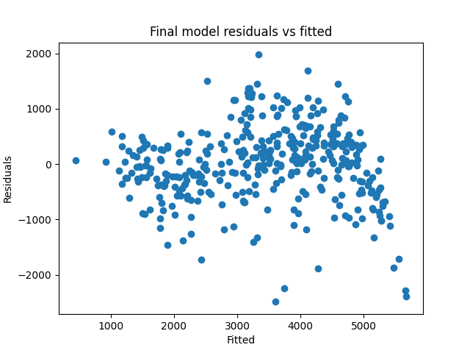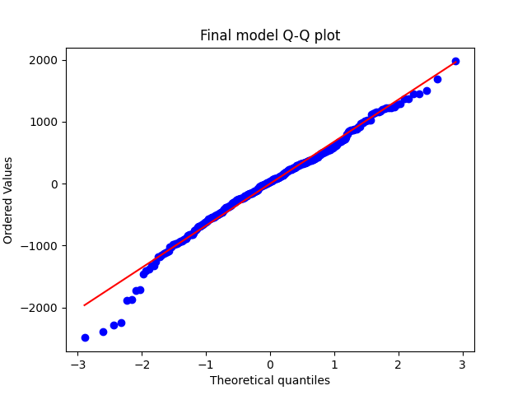
Figure 8a) Fitted Values Figure 8b) Q-Q Plot
Figure 8. Residuals versus fitted values and Q-Q plot for the final model.

Performance on 2012 Data
The final model is applied to the 2012 test set to assess out-of-sample performance. The model yields a negative R² (-0.70), with a root mean squared error of approximately 2,332 rentals per day and a mean absolute error of approximately 2,128 rentals per day. While the model captures some broad seasonal and weather-related patterns, it fails to generalize well to unseen data and substantially underpredicts high-demand days. This indicates that relationships learned from the 2011 data do not transfer cleanly to 2012, likely due to unmodeled nonlinear effects and remaining seasonal structure. These results motivate the use of richer models and additional predictors in later phases of the project.
R2 | RMSE | MAE
-0.704289605 | 2331.885878068468 | 2127.656051677716

Table 5. Test-set performance metrics (R², RMSE, MAE) for 2012.
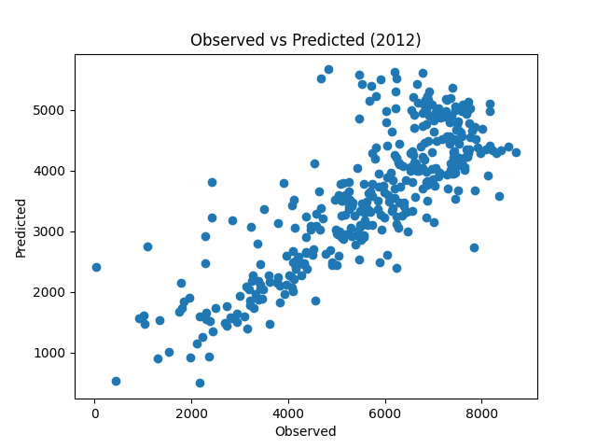
Figure 9. Observed versus predicted daily counts for 2012.
This performance indicates that the relationships learned from the 2011 data do not generalize well to 2012, highlighting the limitations of the linear model and motivating more flexible approaches in later phases of the project.

Discussion
The analysis shows that temperature, seasonality, and weather conditions are the dominant drivers of daily bike sharing demand. Calendar effects such as working day status and month contribute additional explanatory power. Although a temperature-humidity interaction was explored, it was not statistically significant, indicating limited evidence that combined weather effects materially alter demand beyond main effects.
Key limitations include the linear structure of the model, remaining heteroskedasticity, and the lack of a count-based modeling framework. Reasonable extensions include Poisson or negative binomial regression, nonlinear temperature effects, and additional interaction terms.

Conclusion
This report conducted an exploratory analysis of daily bike sharing demand using 2011 data as training and 2012 data as testing. Univariate summaries and regression models showed strong seasonal and weather-driven structure in the data. Temperature, humidity, seasonality, and working day status emerged as the main predictors of demand.
A final model selected by backward elimination retained the most important main-effect predictors of demand. When applied to 2012 data, the model did not generalize well and substantially underperformed on unseen data, highlighting the limitations of the linear model and motivating more flexible approaches in later phases of the project. These results provide a solid foundation for more advanced modeling in later phases of the project.

